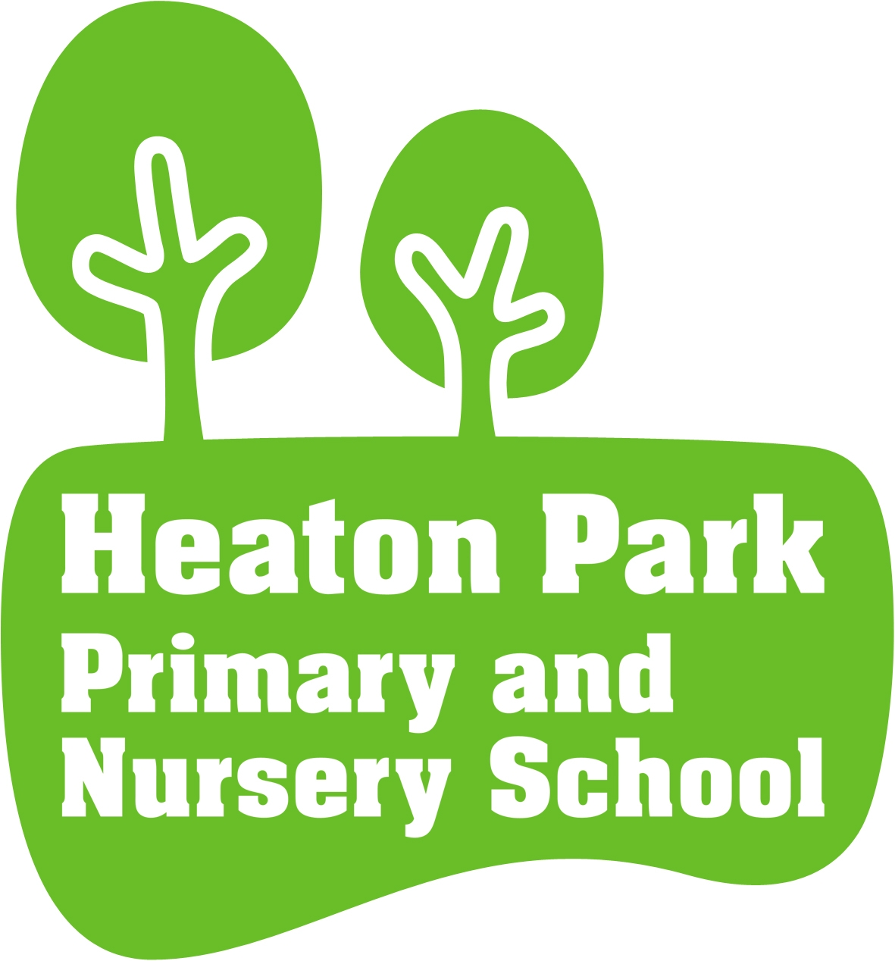

SMSC AND BRITISH VALUES POLICY

Reviewed: February 2016

Next review: February 2018

- School values and ethos

- At Heaton Park Primary School the promotion of pupils’ spiritual, moral, social and cultural education (SMSC) is considered to be fundamental to the life of the school. It is important to all we do.

- Spiritual, Moral, Social and Cultural Development is promoted through all the subjects of the curriculum, through the ethos of the school and through the development of positive attitudes and values and planned time for reflection. This policy supports and reinforces the aims of the school, valuing all children and staff equally and as individuals.
- Heaton Park Primary School approaches the promotion of fundamental British values in line with the

Government’s PREVENT strategy.

These British Values are: democracy; individual liberty; the rule of law; mutual respect; tolerance of those with different faiths and belief. Each is defined below and placed in a school context through the use of examples. It is, without question, everyone’s duty to ensure they do not undermine these fundamental British values as detailed in the current Teacher Standards Part Two: Personal and Professional Conduct.

- Equally British Values are supported by our school values of Enjoy, Aim High and Achieve

- Context

- At Heaton Park Primary School we recognise that SMSC plays a significant part in pupils’ ability to learn and achieve. We therefore aim to provide an education provision that provides children with opportunities to explore and develop:

  - their own values and beliefs
  - their own spiritual awareness

  - their own high standards of personal behaviour
  - a positive, caring attitude towards other people
  - an understanding of a range of social and cultural traditions and choices

  - a comparative understanding of their personal culture and social norms with those of others

- SMSC plays a significant part in ability to learn and to achieve. All curriculum areas have a contribution to make to the child’s SMSC development. Values, principles and spirituality will be explored in the curriculum, especially through Personal, Social, Health and Economic (PSHE) education, RE and Collective Worship. Cultural traditions will be recognised and celebrated, integrity and spirituality of other faith backgrounds will be respected and platforms for exploration of the rights and respects of others explored, ensuring children are given access to explore alternative views and to develop their own.

- All adults will model and promote expected behaviour, treating all people as valuable individuals and showing respect for children and their families. Children will learn to differentiate between what is right and what is wrong in as far as their actions affect other people. They will be encouraged to value themselves and others.

- School and classroom rules will reflect, reiterate, promote and reward acceptable behaviour and provide opportunities to celebrate children’s work and achievements.

- Emotional literacy development will be supported utilising the Personal Development Programme and vulnerable pupils who need extra help will have additional support to develop these skills.

- The importance of relationships between all school staff, parents and governors is recognised. These relationships will be characterised by mutual respect, by positive attitudes, by the willingness to listen and be listened to and by the valuing of all members of the school community.

- We want our children to become responsible, active citizens who participate in democracy and public life with respect for diversity and a commitment to working towards greater community cohesion. PSHE emphasises the difference between right and wrong and respecting and tolerating differences in a very diverse and modern Britain.

- We have planned a curriculum that will enable children to make progress towards these aims. Through engaging lessons and appropriate activities, we can give them all a better understanding of themselves and others in the ‘community of communities’ in which they live.

- We can secure and influence behaviour and attendance and encourage further involvement and commitment to education.

- Spiritual Development

- This relates to the quest for individual identity and the search for meaning and purpose in our existence. It leads towards the understanding of self and others. It has to do with feelings, emotions, attitudes and beliefs. It is not linked solely to a particular doctrine or faith and spiritual development is therefore accessible to everyone.

- Aims and Objectives for Spiritual Development
  - The ability to listen

  - The ability to reflect
  - The ability to sense wonder and mystery in the world
  - The ability to sense the special nature of human relationships

  - To develop the skill of being physically still, yet alert
  - To develop the skill to use all ones senses

  - To develop imagination
  - To encourage times for quiet reflection throughout the school day
  - To develop individual self-esteem and confidence

At our school:
Children are taught to respect themselves and look after their bodies as well as their minds. Our children’s spiritual well-being is developed through reflection on ourselves and being proud of who we are. Children are given opportunities to reflect on their feelings and develop the vocabulary to articulate them. Our creative curriculum encourages children to express themselves and their feelings in many different ways including dance, movement and art and design.

- Moral Development

- Pupils are encouraged to understand the need for a common code and to follow it from conviction rather than because of sanctions or consequences. We work towards an understanding of what is morally right and wrong. From this basis pupils are supported to develop the ability to make judgements and to become increasingly responsible for their own actions and/or behaviour.

- Aims and Objectives for Moral Development
  - To understand the principles lying behind decisions and actions
  - To be able to distinguish between what is morally right and wrong
  - To be able to make choices, accepting and understanding consequences of their actions
  - To move gradually through a taught code of behaviour towards taking responsibility for their own moral decisions

  - To tell the truth
  - To respect the rights and property of others
  - To help others less fortunate than themselves

  - To be considerate to others
  - To take responsibility for their own actions

  - To exercise self-discipline
  - To develop personal high expectations and a positive attitude
  - To conform to school and class rules in order to promote order for the good of all

At our school:
Children are taught to be thoughtful and caring towards each other. We have a zero tolerance policy on the use of derogatory language and children are encouraged to use kind words at all times. Children are taught right from wrong. Our Good to be Green initiative reinforces this which encourages and rewards good choices. Debate and discussion encourage children to form opinions and a strong sense of their moral obligations.

- Social Development

- This enables pupils to become conscientious participants within their family, their class, the school, the local, wider and global community. We aim to offer a balance of the positive, satisfying elements of belonging to a group or society along with the demands, obligations and cooperation such membership requires.

- Aims and Objectives for Social Development
  - To relate positively to others

  - To participate fully and take responsibility in class and school
  - To use appropriate behaviour across a range of situations

  - To work cooperatively with others
  - To use own initiative responsibly
  - To understand our place in our family, school and society

  - To develop emotional literacy in order to be able to express own feelings and understand those of others

  - To be sensitive to the needs and feelings of others

  - To work as part of a group and to interact positively across a range of situations, e.g. clubs, sports activities, visits, music festivals

  - To develop an understanding of citizenship and to experience being part of a caring community

  - To show care and consideration for others e.g. sharing and turn taking
  - To realise that every individual can do something well and have something to offer

At our school:
- Children are taught to respect each other and listen carefully. Circles give children a voice which is heard. They are given the opportunity to vote for their class representative in the school council and learn about the process and the importance of democracy. Our Personal Development Program (PDP) is broad and covers all areas of social development so children maintain friendships and good working relationships with other children and adults. In lessons, children work together in pairs or groups. Kagan structures encourage this interactive learning through sharing and good communication practices. Children are given the tools to develop independence whilst being able to work positively with others. Our various clubs also help children develop social skills.

- Cultural Development

- At the heart of cultural development lies the necessity to develop a sense of personal identity, whilst at the same time acquiring awareness, understanding and tolerance regarding the cultural traditions and beliefs of others.

- Aims and Objectives for Cultural Development

  - To develop a sense of belonging to pupils’ own culture and being proud of their cultural background

  - To respond to cultural events

  - To share different cultural experiences
  - To respect different cultural traditions

  - To understand codes of behaviour, fitting to cultural tradition

  - To develop a balanced approach to retaining the traditions of a mixed faith society, whilst perceiving in a positive light the contribution of other cultures, past and present

  - To develop an awareness, recognition and appreciation of the Arts, e.g. Music, Art, Drama and

Literature
  - To develop an understanding of different cultures and beliefs

  - To appreciate the values and customs of other ethnic and faith groups which make up modern British society, and the world beyond

At our school:
Through our broad curriculum children encounter different cultures and are encouraged to respect and learn from them. Children reflect on their own identities and celebrate their differences. Special events, such as Diversity Week, give the children wider opportunities to learn about different cultures, backgrounds and religions. Children at Heaton Park come from many different countries and speak many languages. We celebrate this by learning important words and phrases in different languages.

- British Values: Aims and School Context

British Values are entwined in our ethos and values and are part of the spiritual, moral, social and cultural development of our children. British Values are also promoted more discretely through themed assemblies, links to PSHE and RE lessons and through cross-curricular topic work.

- Democracy

  - To understand how they can influence decision making through a democratic process
  - To understand and respect the democratic process

  - To understand how to argue and defend a point of view
  - To understand the importance of team work

In school we promote the importance of democracy through such things as:

  - The free and fair electoral process for student positions of responsibility such as School Council

  - Pupil Voice on school decisions – e.g. agreeing school and class rules, School Council discussions, Pupil Voice Surveys

  - Students choosing activities for school events e.g.
  - Pupils being encouraged to consider alternative pathways in lessons

- Rule of Law

    - To be able to recognise the difference between right and wrong and apply this to their own lives

    - To be able to accept responsibility for their behaviour

    - To understand the consequences of their behaviour and actions
    - To be able to resolve conflict

    - To understand how they can contribute positively to the lives of those living and working in the locality and society more widely

    - To understand that living under the rule of law protects them and is essential for their well-being and safety

In school we promote the importance of rule of law through such things as:
  - Our school’s Rules

  - A shared set of classroom rules
- It's Good to be Green
  - Marking and feedback, as well as homework, policies set clear boundaries

- Individual liberty

  - To understand rights and responsibilities
  - To understand the concept of freedom of choice

In school we promote the importance of individual liberty through such things as:
- Pupils encouraged to express their opinion in a polite and thoughtful manner
- The range of extra-curricular activities and clubs on offer

  - Encouraging children to think of the consequences of their choices with respect to their actions

- Mutual respect and tolerance of those with different faiths and beliefs

  - To be reflective about their own beliefs, religious or otherwise that inform their interest in and respect for different people’s faiths, feelings and values

  - To be reflective about their own experiences

  - To be able to investigate and offer reasoned views about moral and ethical issues and being able to understand and appreciate the viewpoints of others

  - To use a range of social skills in different contexts, including working and socialising with pupils from different religions, ethnic and socio-economic backgrounds

  - To participate in a variety of communities and social settings, cooperating well with others

  - To understand and appreciate of the range of different cultures within school and further afield as an essential part of their preparation for life in modern Britain

  - To understand, accept, respect and celebrate diversity as shown by their tolerance and attitudes

In school we promote the importance of mutual respect and tolerance through such things as:

  - Clear boundaries of behaviour
  - Our RE curriculum

  - Assembly themes, stories and visitors that encourage an open understanding of respect for and understanding of a range of faiths that are part of British culture

  - Our charitable work with a range of local, national and international charities

  - Our enforcement of a smart dress code

- Partnerships with parents, carers and the wider community

- The development of a strong home-school agreement is regarded as highly important, enabling parents and teachers to work in an effective partnership to support pupils in their SMSC development.

- Visitors are welcomed to participate in and contribute to school activities and curriculum delivery. Links with the local community including local churches and other places of worship are fostered.

- Children will be taught to appreciate and take responsibility for their local environment and the school supports the work of a variety of charities locally, nationally and globally.

9 Monitoring and evaluation

- Provision for SMSC is monitored and reviewed on a regular basis. This is achieved by:
- SMSC and British Values learning walk

  - monitoring of PSHE planning, teaching and learning

  - discussions at staff and governors’ meetings
  - audit of related policies and their consistent implementation as a whole school

  - Inclusion in the school improvement plan (as appropriate)

  - collating evidence of children’s work and experiences including the WOW floor books

  - Pupil voice - sampling of pupil focus groups to evaluate impact on their knowledge, understanding, skill development and attitudes

- Implementation of the policy and review

- The implementation of this policy and the planning and teaching of SMSC is the responsibility of all staff.

- The policy will be reviewed in line with the school policy review cycle

